Reporting Guidelines and Channels at WRC

- Introduction
Reporting is the most important feature of non-profit organizations which governs their effective and efficient working. Reports are basic tool in organizations for receiving feedback about the progress made. Management uses reports to see if activities of an organization are going according to plan. The bottom line is, if results of activities are below planned targets then various corrective measures are taken at various levels.
A good reporting ensures the effective and timely implementation of project activities. The advantages of a good reporting mechanism are manifold. The first and foremost advantage is that the higher management and donors are well informed on the progress of project activities. Secondly, all activities are timely recorded and as such the lessons learnt and challenges are available for review later too. Apart from that, there is more accountability on the part of the staff, therefore, all staff members function vigilantly.
  - Important Tips for Drafting Report
- Feel good and realize that all the work or the field activities will get reflected in your report.
- Structure your report with a clear understanding of its objective. This will help you to structure your report, filter unnecessary descriptions and keep it specific and simple
- Start earlier as soon as possible on the report and do not wait for the work to get completed. You can write good reports only if you start working on your report much earlier
- Arrange information in a logical way and take care the formatting and structure are well balanced
- Use spell check, stick to the point and use simple words and sentences
- Make sure the layout is well organized

  - Key Elements to Consider in Writing Report
- Collect the information needed. Important sources are: periodic reports for field, notes which have been written earlier, project proposal and other key documents, information from your monitoring system, interviews with staff/target groups, key notes and minutes of meetings organized with project team, etc.
- Arrange your information in a logical way and take care the structure is well balanced.
- Make use of heading, sub-heading, paragraphs, sub-paragraphs. Try to make the paragraphs of the same length.
- Write in the language of your reader – not childish or over-sophisticated
- Avoid long and complicated sentences
- If needed, use footnotes to explain certain concepts/ideas
- Use spell check and make sure the layout is well organized

  - Characteristics of Good Report

Simplicity: The language should be as simple as possible so that a report is easily understandable

Relevancy: The facts presented in a report should not be only accurate but also be relevant.

Clarity: The language should be lucid and straight, clearly expressing what is intended to be expressed

Brevity: A report should not be unnecessarily long, so that the patience of the reader is not lost and there is no confusion of ideas.

Punctuation: Punctuations have to be carefully and correctly used otherwise the meaning of sentences may be misunderstood or misrepresented

Readability: Presentation and the diction (use of words) shall be such that the readers find it attractive and feel compelled to read the report from the beginning to the end.

Accuracy: A report should be accurate when facts are stated in it. It should not be biased with personal feelings of the writer.

Logical Sequence: The points in a report should be arranged in a logical sequence, step by step and not in a haphazard manner.

Unbiased Recommendation: If recommendations are made at the end of a report, they must be impartial and objective.

Presentation: A report needs an attractive presentation. Provide a catchy and smart look to the report for the attention of the reader.

- Types of Reporting
There are two types of reporting: External Reporting and Internal Reporting
2.1. External Reporting
External reporting involves all reports that are to be prepared and sent to the donors and other key stakeholders. These reports inform the donors and project partners about the progress that has been made during the reporting period. Usually, the donors provide their own templates for such reporting. Thus, all activities conducted in the field in relevance to the project along with indicators, statistical data of target groups, lesson learned and success stories and any potential challenges constitute the content of the report.
According to the research on Donor Reporting, the donor reporting requirement is driven by two broad objectives:
- To account for the use of allocated funds and produce annual statistics on global results
- To gauge and steer program performance
External reports developed for donors are submitted as per their requirements, which could be,
- Final Project Narrative and Financial Reports
- Periodic Reports, including Annual, Biannual (six-monthly), Quarterly and Monthly Narrative and Financial Reports
- Baseline Assessments, Training Need Assessment (TNA), Rapid Situation Analysis (RSA), Area Mapping, Stakeholders Analysis, Gender Sensitive Need Assessment and any other Study Reports
- Monitoring, End Line Evaluation and Impact Analysis Reports
- Events (trainings, workshops, seminars, round table conference, etc.) Reports
- Special Reports
The following four types of information, usually ask by the Donor:
- What the results are so far of the implementation of the project (Impact development information)
- Which activities have been implemented so far (activity implementation information),
- How was the money spent? (finance/budget information)
- Information about the project staff (management information)

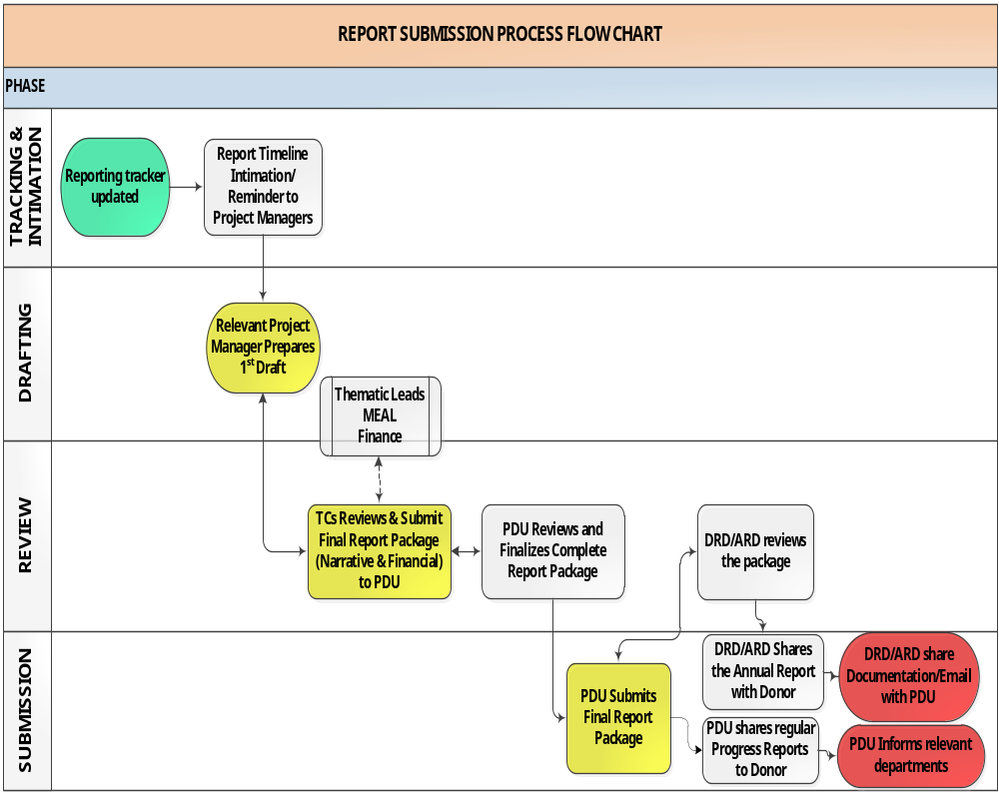2.1.1. External Reporting Channel at WRC

Tier 1 – Tracking and Information Collection: Field staff is the main source for collecting and provide accurate information for donor reporting. Program Officers/Lead at each section/department in the office will be responsible for getting the field staff to send pertinent information about all the activities and accomplishments attained during the reporting period along with all Means of Verifications (MoVs) and other required documents.
Tier 2 - Drafting: The Program lead is responsible for compiling the data received from the field on the donor’s prescribed template or WRC predefined format. The report should include pictures of the events conducted, the exact number of target groups (gender and age segregated), number and types of activities done, training sessions, target groups selection process (where relevant), etc. The report should also include a work plan or activities/targets for the next reporting period to inform the donor and management about the future plan of action.
Tier 3 – Review and Refining: The report developed by the relevant program staff should be sent to Program Development Unit (PDU). The PDU is responsible for reviewing, editing and provide suggestions/recommendation on the report as well as verifying the statistical/quantitative data against MoVs/sources of verification received from the field. Once the information provided in the report is cross checked and finalized, the report should be forwarded to the respective department/section for addressing the comments and incorporating suggestions.
Tier 4 – Final Settlement and Submission: The refined version of the report should be sent to higher management for perusal and approval. After approval, the report should be sent to the donor at the appointed time by the project focal person with the higher management in the loop.
Above all, the contents of external monthly and quarterly external should include the following contents:
- Cover page/Title page
- Table of contents and acronyms
- Project description/Executive Summary (max 1 page)
- Background and socio-economic situation in the targeted areas (max 1 page)
- Main accomplishments during the reporting period
- Details of outputs, outcomes and activities
- Statistical information (gender and age segregated) of all target groups
- Training details in case of a training (attendance sheet, agenda, manual, travel request, bills of accommodation/logistics and any other expenses incurred, etc.)
- Details of mobilization sessions (travel request, logistic information and pictures)
- Proceedings of meetings/sessions (Pictures, travel request, attendance sheets, logistic information, meeting minutes)
- Details of advocacy sessions, seminars, conventions, etc. (along with all MoVs in soft (scanned) and hard form)
- Case studies, lesson learned and success stories recorded during the implementation in the reporting period
- Pictures of activities (captioned) and other visual record
- All the documents should be duly verified by competent authorities/management

  - Internal Reporting
Internal reporting system deals with the flow of information from the field to the respective section/department at regional or head office and eventually to the higher management. A proper internal reporting mechanism at each level will ensure efficient flow of information and all the tiers of management will be well informed of the progress of the project. Another important aspect for an effective reporting mechanism is that hierarchical chain of command is strictly followed at each level within the organization.

2.2.1 Internal Reporting Channels at WRC
- The field staff of a specific project will send weekly and monthly updates of the activities conducted during the week/month to the project focal person at regional and head office along with scanned copies of means/sources of verification. The copies of MoVs can also be sent in the hard form if a scanner is not available at the field level;
- Weekly/monthly reports will be compiled by the program focal person and will be shared with respective program lead for their perusal. The report should also include details of technical backstopping provided for overcoming the challenges in the field;
- The program lead will be expected to provide feedback on the reports and provide inputs, when and where necessary;
- The program lead can also seek support from PDU for their review, inputs and guidance for improvement.
2.2.2 Coordination among field staff and respective project leads
- Monthly coordination meetings amongst the project staff (PM/PC) should be held so that everyone is on the same page and there is a clear understanding about future actions. During these meetings the staff can discuss the project details, personnel issues, grievances, etc.
- It needs to be made sure that our job is to resolve issues and not malign our staff by our authoritative attitudes. Temperaments and attitudes should be controlled because malignant attitudes and raised voices culminate in malignant behaviours and feelings. A conducive working atmosphere is the key to effective and efficient implementation of the activities.
- This is to be made sure that all instructions given at all levels are clearly communicated. Vague instructions will result in botched up outputs and efficiency. All instruction to field staff should be given by the respective departments.
- Higher management should provide technical backstopping when a situation is raised up where the department head fails to handle or when finances are involved.

